**Defence Council**

The Defence Council is the senior departmental committee of the Ministry of Defence. It is chaired by the Secretary of State, and comprises the other ministers, the Permanent Under Secretary, the Chief of Defence Staff and senior service officers and senior officials who head the armed services and the department’s major corporate functions. It provides the formal legal basis for the conduct of defence in the UK through a range of powers vested in it by statute and Letters Patent.

**Members**

[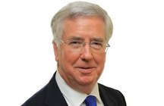](https://www.gov.uk/government/people/michael-fallon)

[**The Rt Hon Michael Fallon MP**](https://www.gov.uk/government/people/michael-fallon)

[Secretary of State for Defence](https://www.gov.uk/government/ministers/secretary-of-state-for-defence)



[**Earl Howe**](https://www.gov.uk/government/people/lord-howe)

[Minister of State](https://www.gov.uk/government/ministers/minister-of-state--34),

[Deputy Leader of the House of Lords](https://www.gov.uk/government/ministers/deputy-leader-of-the-house-of-lords)

**Unpaid**

[**Philip Dunne MP**](https://www.gov.uk/government/people/philip-dunne)

[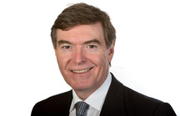](https://www.gov.uk/government/people/philip-dunne)

[Parliamentary Under Secretary of State and](https://www.gov.uk/government/ministers/parliamentary-under-secretary-of-state-defence-equipment-support-and-technology)

[Minister of State for Defence Procurement](https://www.gov.uk/government/ministers/minister-of-state-minister-for-defence-procurement)



[**Penny Mordaunt**](https://www.gov.uk/government/people/penny-mordaunt)

[Minister of State for the Armed Forces](https://www.gov.uk/government/ministers/minister-of-state-minister-for-the-armed-forces)



[**Mark Lancaster TD MP**](https://www.gov.uk/government/people/mark-lancaster)

[Parliamentary Under Secretary of State](https://www.gov.uk/government/ministers/parliamentary-under-secretary-of-state-defence-personnel-welfare-and-veterans)

[and Minister for Defence Personnel,](https://www.gov.uk/government/ministers/parliamentary-under-secretary-of-state-defence-personnel-welfare-and-veterans)

[Welfare and Veterans](https://www.gov.uk/government/ministers/parliamentary-under-secretary-of-state-defence-personnel-welfare-and-veterans)



[**Julian Brazier MP**](https://www.gov.uk/government/people/julian-brazier)

[Parliamentary Under Secretary of State](https://www.gov.uk/government/ministers/parliamentary-under-secretary-of-state-and-minister-for-reserves)

[and Minister for Reserves](https://www.gov.uk/government/ministers/parliamentary-under-secretary-of-state-and-minister-for-reserves)

[**Jon Thompson**](https://www.gov.uk/government/people/jon-thompson--3)

Permanent Under Secretary

[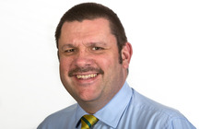](https://www.gov.uk/government/people/jon-thompson--3)

(Permanent Secretary@ the MoD)

[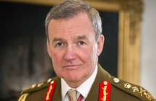](https://www.gov.uk/government/people/nicholas-houghton)

[**General Sir Nicholas Houghton GCB CBE ADC Gen**](https://www.gov.uk/government/people/nicholas-houghton)

Chief of the Defence Staff

[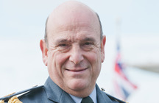](https://www.gov.uk/government/people/stuart-peach)

**[Air Chief Marshal Sir Stuart Peach](https://www.gov.uk/government/people/stuart-peach)**

**[KCB CBE ADC BA MPhil DTech DLitt FRAeS RAF](https://www.gov.uk/government/people/stuart-peach)**

Vice Chief of the Defence Staff

[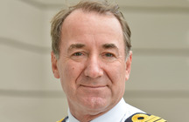](https://www.gov.uk/government/people/george-zambellas)

[**Admiral Sir George Zambellas KCB DSC ADC**](https://www.gov.uk/government/people/george-zambellas)

First Sea Lord and Chief of Naval Staff



**[General Sir Nicholas Patrick Carter](https://www.gov.uk/government/people/nicholas-patrick-carter)**

**[KCB CBE DSO ADC Gen](https://www.gov.uk/government/people/nicholas-patrick-carter)**

Chief of the General Staff

[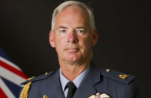](https://www.gov.uk/government/people/andrew-pulford)

**[Air Chief Marshal Sir Andrew Pulford](https://www.gov.uk/government/people/andrew-pulford)**

**[KCB CBE ADC RAF](https://www.gov.uk/government/people/andrew-pulford)**

Chief of the Air Staff

[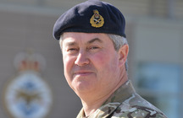](https://www.gov.uk/government/people/richard-barrons)

[**General Sir Richard Barrons KCB CBE ADC Gen**](https://www.gov.uk/government/people/richard-barrons)

Commander of Joint Forces Command

[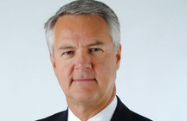](https://www.gov.uk/government/people/vernon-gibson)

[**Professor Vernon Gibson**](https://www.gov.uk/government/people/vernon-gibson)

MOD Chief Scientific Adviser

[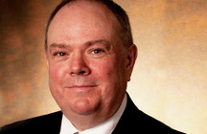](https://www.gov.uk/government/people/bernard-gray--2)

[**Bernard Gray**](https://www.gov.uk/government/people/bernard-gray--2)

Chief of Defence Materiel



[**Louise Tulett CBE**](https://www.gov.uk/government/people/louise-tulett)

Director General of Finance

**-----------------------------------------------------------------------------------**

The [letters patent](http://en.wikipedia.org/wiki/Letters_patent) constituting the Defence Council vest it with the power of command over [Her Majesty's Forces](http://en.wikipedia.org/wiki/British_armed_forces) and give it responsibility for their administration, or in the words of the letters patent:

"*...to administer such matters pertaining to Our Naval Military and Air Forces as We through Our Principal Secretary of State for Defence direct them to execute And to have command under Us of all Officers Ratings Soldiers and Airmen of Our Naval Military and Air Forces...*".

<https://www.thegazette.co.uk/London/issue/43277/page/2545>

<https://www.gov.uk/government/organisations/ministry-of-defence/groups/defence-council>